Synergizing Intelligence: The Intersection of NLP and Knowledge Graphs

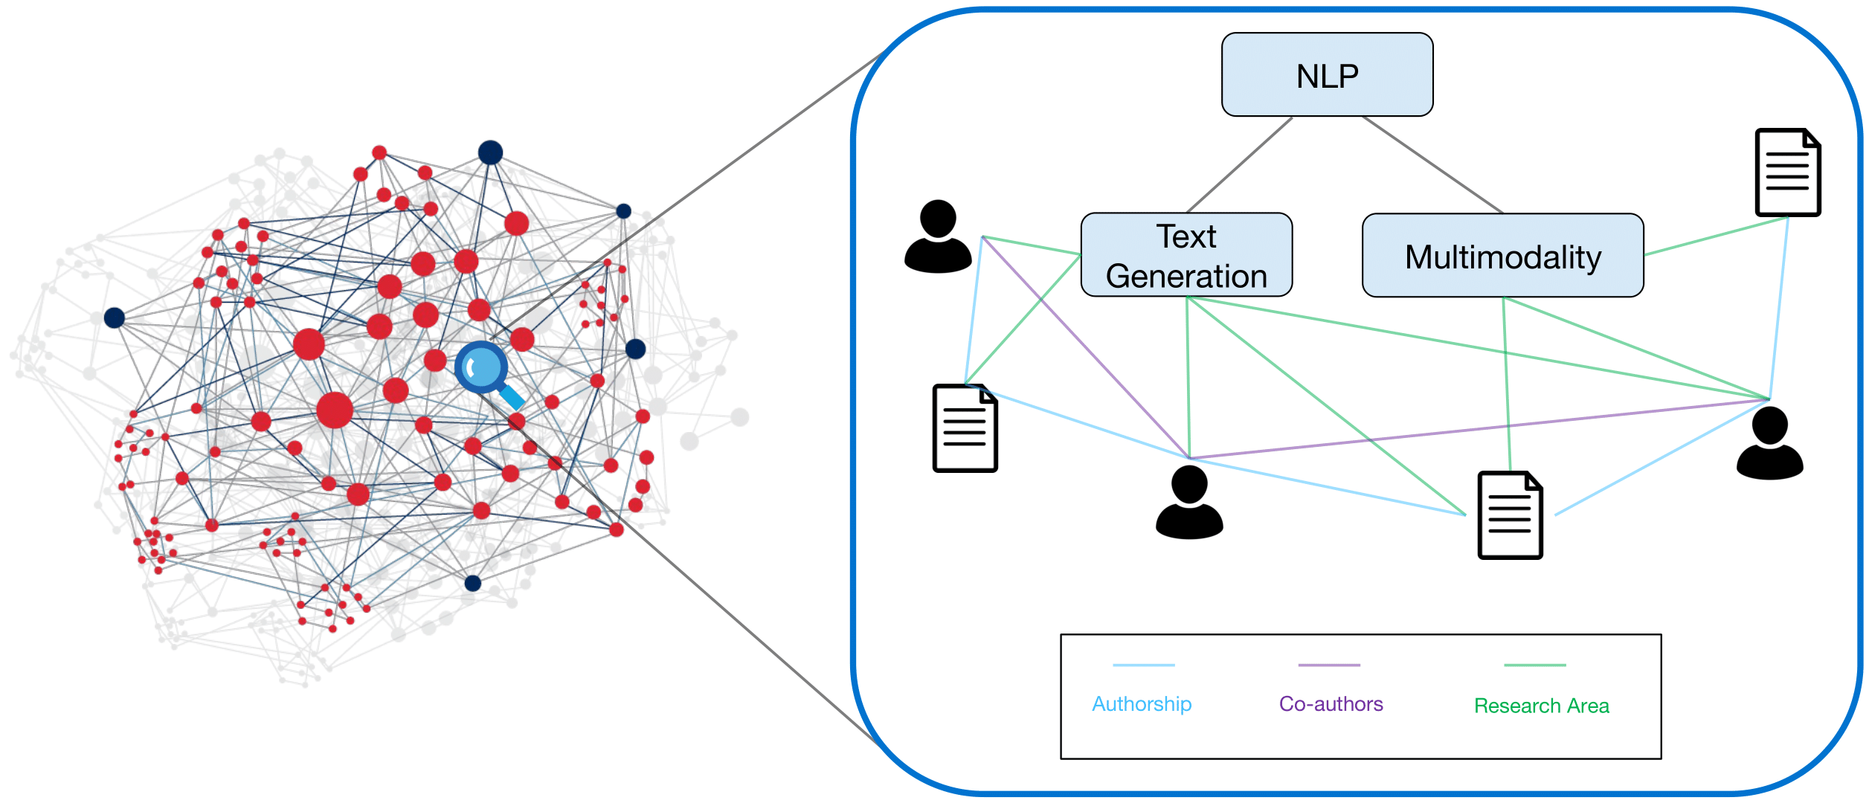

**Introduction to NLP and Knowledge Graphs:**

NLP is a branch of AI that is focused on helping computers learn from text similar to humans. It combines the linguistic rules, and rule-based modeling to capture the semantic meaning of text. NLP can be used in many machine learning tasks to enhance the results. It is commonly used in Spam email detection, Machine translation, Virtual agents and Chabot, Social media sentiment analysis, and Text summarization.

A Knowledge Graph (KG) is a directed labeled graph in which domain-specific meanings are associated with nodes and edges. In KG each node represents an entity which can include people, places, events, and concepts. An edge between 2 nodes represents the relationship between these 2 nodes. KG is used to organize data and integrate data according to an ontology, which is called the schema of the knowledge graph. KGs can be created from scratch using structured or unstructured data and with the help of a domain expert.

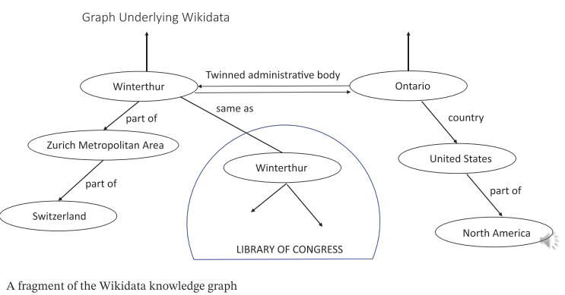

**Challenges in NLP:**

NLP is a very strong tool but still, it has its limitations.

1. **Contextual words and phrases and homonyms:** Some words and phrases change their meaning depending on the context. Some words even have the same pronunciation or spelling but have different meanings. As humans, we can understand the meaning of these words and phrases but NLP cannot differ the context and understand the true meaning.
2. **Irony and sarcasm:** NLP is unable to understand sarcasm as the writer means the opposite of whatever the text means. NLP fails to understand it as it relies on literal dependency and the lack of consideration for tone and intonation.
3. **Colloquialisms and slang:** For NLP, informal words, expressions, idioms, and cultural jargon provide a variety of challenges, particularly for models meant for widespread use. Furthermore, new terms appear daily since cultural slang is always evolving and growing.
4. **Domain-specific language:** Distinct sectors and industries frequently speak in quite distinct ways. For example, an NLP processing model required for processing legal texts would be much different from one needed for healthcare. Though there are many analytic tools available these days that are trained for particular disciplines, more specialized companies might need to develop or train their models.

**Strengths of Knowledge Graphs**

Knowledge Graphs are a great tool to capture the semantic meaning and relations of entities which makes them useful for many applications:

1. **Structural Knowledge Representation:** KGs provide a structured representation of knowledge. This is easy to understand, navigate, and query and helps users to understand complex data.
2. **Decisiveness:** KGs help machines and applications to make well-informed decisions as they provide explicit and well-defined relationships between entities. This enables machines and applications to reason and infer new knowledge based on the available information.
3. **Domain-Specific Knowledge Capture:** Knowledge graphs may be customized to represent relationships and information unique to a certain area. This makes it possible for analysis, insights, and applications in specialized fields like finance, healthcare, or scientific research to be more precise and focused.
4. **Interpretability and Explainability:** Human interpretation and explanation are goals for knowledge graph design. A clear knowledge of the data and the logic underlying the connections is made possible by the explicit depiction of entities and relationships, which improves interpretability and makes it simpler to spot and correct any biases or mistakes.

**Semantic Enrichment with Knowledge Graphs:**

Integrating KGs and NLP can lead to the Semantic Enrichment of textual data. When a KG is made using a machine learning model and uses NLP to gain insights into nodes, edges, and labels, it is called a process of semantic enrichment.

Entity recognition and linking (ERL) is a crucial step in the integration of KGs with NLP. ERL includes 2 major steps which include the process of identifying entities from a text which can be people, places, events, concepts, etc., and forming nodes for the identified entities. The next step involves mapping the nodes and linking them with the identified relations between the entities

ERL can be done using different techniques like rule-based systems, machine learning, and deep learning. All these techniques can identify the links and entities from a text with high accuracy which can help in a better structured representation of a text.

KG with Semantic Enrichment can deeply understand the semantic meaning of the text and can be used in various applications such as chatbots, information retrieval systems, and Recommendation systems.

**Ontologies and Schema Alignment:**

Ontologies play a crucial role in building Knowledge Graphs (KGs) and enhancing Natural Language Processing (NLP). Ontologies are a formal way of representing knowledge that defines concepts, properties, and attributes to and relation between them.

Ontologies can be used to improve KG as they provide a shared vocabulary to describe entities and relations. Ontologies can also be used to enhance NLP tasks like ERL by providing more information about entities and relations

Ontologies can also help to improve schema alignments in KGs by providing shared vocabulary from different sources. Schema alignment is a process of mapping the schema of multiple data sources into a single schema which can be used to integrate into a KG. Schema alignment can be challenging due to the undocumented semantics of the different schemas.

**Applications of the Integrated Approach:**

Information retrieval, banking, healthcare, and other industries have benefited from the integration of NLP and KGs. Here are a few instances of practical uses:

1. **Information Retrieval:** In the field of information retrieval, KGs can be used to improve search results and recommendation systems. For example, Google’s Knowledge Graph is a KG that provides users with relevant information about their search queries. KGs can also be used to improve question-answering systems by providing more accurate and structured answers.
2. **Healthcare:** A healthcare knowledge graph (HKG) is a domain-specific knowledge graph designed to capture medical concepts such as drugs, diseases, genes, phenotypes, and so on, and their relationships in a structured and semantic way. HKG enables users to query from the KG and retrieve, manipulate, and analyze data in a structured and consistent way.
3. **Banking:** A financial knowledge graph (FKG) is a KG that integrates financial data from various sources like financial reports and news articles. FKG can be used to identify investment opportunities and predict market trends.

**Technological Solutions and Tools:**

Several existing tools and frameworks facilitate the integration of NLP and KGs:

1. **OpenKG:** is an open-source platform that provides tools to form and manage a KG. It also includes tools for data ingestion, ERL, and schema alignment.
2. **GATE:** General Architecture for Text Engineering (GATE) is an open-source framework for NLP that provides tools for building and managing KGs. It also includes tools for ERL and ontology-based annotation.

Recent advancements and research in this area focus on improving the accuracy and efficiency of ERL and schema alignment.

**Future Directions and Challenges:**

There are several potential avenues for further research and development in bridging the gap between NLP and KGs.

1. **Multilingual KGs:** Developing multilingual KGs can help improve cross-lingual NLP tasks such as machine translation and cross-lingual information retrieval.
2. **Dynamic KGs:** Developing dynamic KGs that can adapt to changes in the real world can help improve the accuracy and relevance of KGs.
3. **Interactive KGs:** Developing interactive KGs that can be updated and maintained by users can help improve the quality and completeness of KGs.

Researchers and practitioners may face several challenges in implementing and scaling integrated NLP and KG systems. Some of these challenges include:

1. **Data quality:** Ensuring the quality and accuracy of data used to build KGs can be challenging, especially when dealing with unstructured and noisy data.
2. **Scalability:** Scaling KGs to handle large volumes of data can be challenging, especially when dealing with distributed and heterogeneous data sources.
3. **Privacy and security:** Ensuring the privacy and security of data used to build KGs can be challenging, especially when dealing with sensitive data such as personal health information.

**Conclusion:**

Bridging the gap between NLP and KGs can lead to several benefits such as improved information retrieval, knowledge representation, and decision-making. Real-world applications of the integrated approach include healthcare, finance, and information retrieval. Existing tools and frameworks facilitate the integration of NLP and KGs. Future directions for research and development include developing multilingual and dynamic KGs, and interactive KGs that users can update and maintain.